AWS Lambda vs. Google Cloud Function
Bingxuan Ying for CS5287

Introduction
Serverless computing is a new trend in software development. The functions of the application will be deployed separately instead of in one instance. There are a lot of cloud service companies provide serverless computing today, however, there are performance difference among services they provide. So, in this research article, the difference between AWS Lambda and Google Cloud Function will be studied.

AWS Lambda And GCF Description

AWS Lambda
AWS Lambda is a serverless, event-driven compute service that lets you run code for virtually any type of application or backend service without provisioning or managing servers. You can trigger Lambda from over 200 AWS services and software as a service (SaaS) applications, and only pay for what you use [1].

Goolge Cloud Function
Google Cloud Functions is a popular serverless compute function that is available on Google Cloud Platform. Serverless functions help developers innovate faster, scale easier and reduce operational overhead, removing the burden of managing underlying infrastructure when updating and deploying code. Most enterprises use serverless functions as part of a broader hybrid environment, covering both cloud and traditional technologies [2].

Terminologies

Abbreviations and Acronyms
AWS is used for Amazon Web Services
GCP is used for Google Cloud Platform
GCF is used for Google Cloud Function

Units
- “msec” is used for micro-second

Test Design
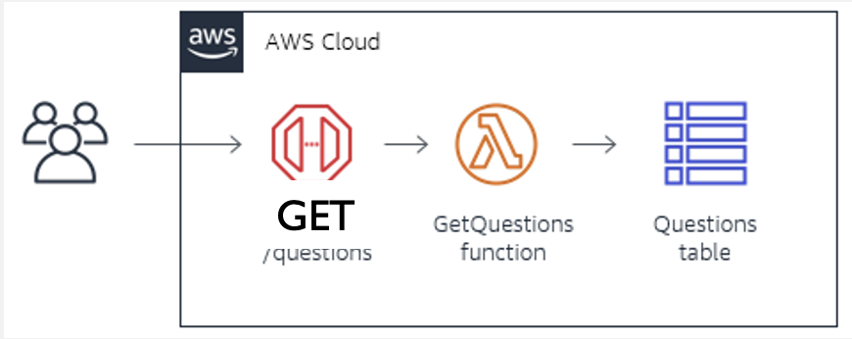
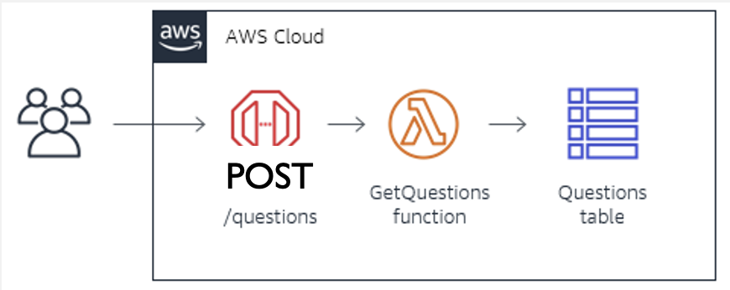
200 and 2000 number of GET and POST requests will be made to serverless service on AWS and GCP. The request script is written in JavaScript adopting Axios framework. The script will be run on AWS EC2 to make request to AWS Lambda, and it will be run on GCP Computing Instance to make request to GCF. In this case, the hardware performance difference and latency difference will be minimized.
Minimum, median, maximum request time will be record as the metric to compare, as well as the failure rate.

Test Results

AWS Lambda
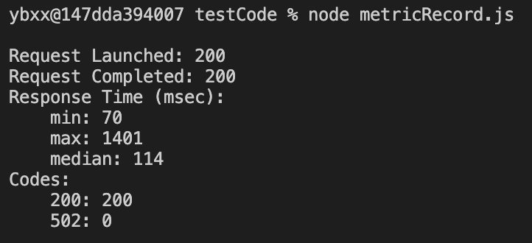
200 Requests
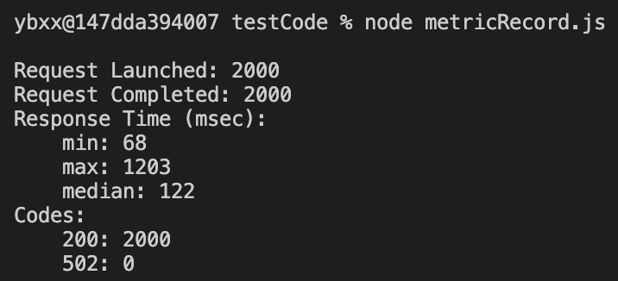
2000 Requests

Google Cloud Function
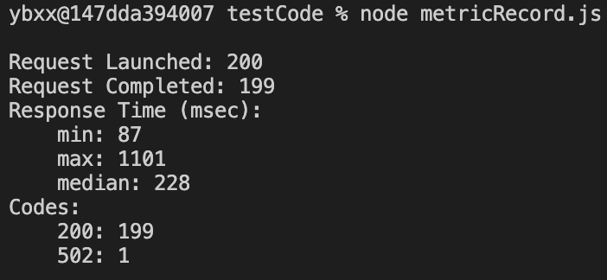
200 Requests
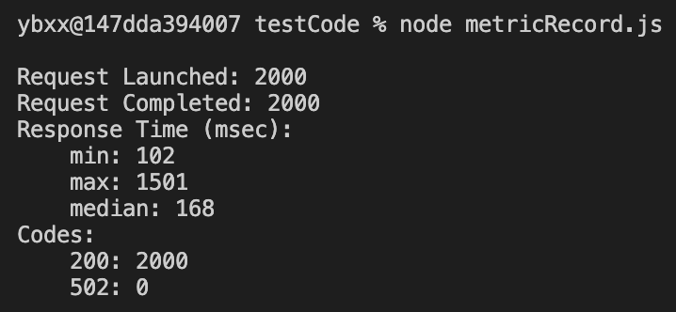
2000 Requests

Analysis

Ease of Deloyment
Ease of deployment is important to keep one service popular among all users and keep the service be competitive among all similar services on the market. Steps taken to establish on lambda function of two services are listed below:
AWS Lambda | Google Cloud Function

- Fill function properties  - Create trigger and link to the function  - Write function code | - Fill function properties  - Write function code

From the table above, AWS Lambda takes three steps while GCF only takes two. The extra step of the AWS Lambda is adding trigger of the lambda function. In this case, we can say the GCF is more convenient to deploy than AWS Lambda.

Availablity
 | AWS Lambda | Google Cloud Function
200 Requests | Average 0 Failed | Average 1 Failed
2000 Requests | Average 0 Failed | Average 0 Failed

On the test result section, we can see that both services have no downtime. However, Google Cloud Function shows average 1 failure on 200 requests. It might be because of network turbulence. Also, just noted, the experiment sample is not large.

Network Performance & Stability
The network performance between AWS Lambda and Google Cloud Function are also evaluated. As the test result suggests, the minimum response time and median response time of AWS Lambda is a little bit lower than Google Cloud Function; however, the maximum response time of Google Cloud Function is a bit faster. Overall, we can AWS Lambda has a bit better performance than Google Cloud Function.

References
- https://aws.amazon.com/lambda/ (references)
- https://cloud.google.com/gcp?utm_source=google&utm_medium=cpc&utm_campaign=na-US-all-en-dr-bkws-all-all-trial-e-dr-1011347&utm_content=text-ad-none-any-DEV_c-CRE_491414383178-ADGP_Desk%20%7C%20BKWS%20-%20EXA%20%7C%20Txt%20~%20GCP%20~%20General_GCP-KWID_43700060017842270-aud-1436107373682%3Akwd-289154591473&utm_term=KW_gcp%20cloud%20functions-ST_gcp%20cloud%20functions&gclid=Cj0KCQiA_c-OBhDFARIsAIFg3ezMzDHt4E_NSDDWqZ_i5o0EsZxW8J7m6na0-SUJxJByZ7747kKDReoaAmEMEALw_wcB&gclsrc=aw.ds (references)

